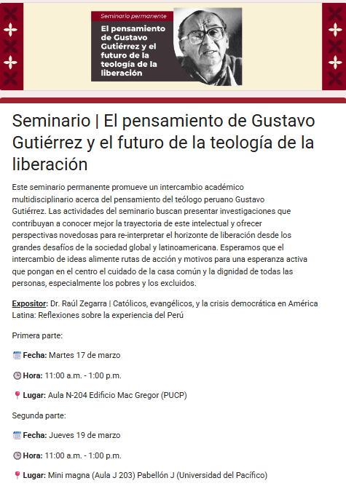
https://docs.google.com/forms/d/e/1FAIpQLSc3uLwDkQxyuOmQu1q7bEDd2G0AjUsUFaPCK4HmVa-o7-He5Q/viewform

